Start at WELL entrance, exterior
- The WELL – LEED gold, pharmacy Rx disposal, Peak Adventures Bike Shop
- Solar panel ready PS#3 & The WELL Solar Panels
- Hornet Stadium – artificial turf
- Induction Lighting Poles
- Lot 9 & 10 – Future home of solar farm
- Capital Public Radio – Garden (beehives, demonstration kitchen, Food & Sustainability Reporter)
- Benicia Hall Bike Compound
- Benicia Hall Drought Tolerant Landscape
- Library Solar Panels
- Ground to Grounds – Java City Library breezeway
- Library Fountain – Turned off for water conservation
- Library Quad – Future home of rain garden, bio swales, OWP water grant info
- Redwoods – Mulching
- Redwoods – Tree Campus USA, Arboretum
- Library Quad – Bike compound
- Central Plant – Smart Grid
- Brighton Hall – Sustainability plants, retaining wall
- Humboldt – Toilets/bathroom fixture replacements
- Sequoia Hall – Pony Express, original sustainable transportation
- Riverside – Engineering dept., Sr. students projects at STORC/teaser for STORC
- Recycling Receptacles
- Guy West Bridge – River, bike path, mile 7 adoption
- EH&S – Storm water mgmt
End at STORC
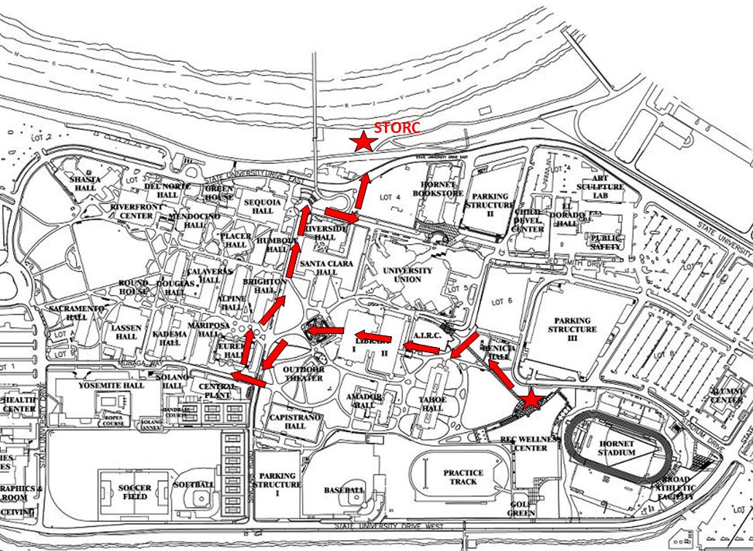

- The WELL (spoken at: The front of the WELL and inside the WELL lobby)
The WELL was awarded LEED Gold in 2010 for its many sustainable features like skylights and windows that let in natural lighting, gym wall panels made from the agricultural waste sunflower seeds and even—as you can see beneath your feet—broken Heineken bottles that were used as filler for the construction of the lobby floor. This building also features the Peak Adventures Bike Shop and our WELLness Center Pharmacy which features a collection bin for anyone in the Sacramento area to bring their unused or expired medication for responsible destruction ensuring that such items will not be flushed down the drain further polluting our drinking water.

- Solar Panels: The WELL and PS 3 (spoken at: leaving from the WELL, walking)
There are 952 solar panels located on top of the WELL, visible from the Hornet Stadium stands. Currently, there are no solar panels located on top of Parking Structure 3, however the infrastructure was built to be solar-ready, with an estimated size of 2 megawatts of solar panels.

- Hornet Stadium – artificial turf (spoken at: leaving from the WELL, walking)
Because we understand lawn-watering is the largest source of irrigation water use, we have changed out the football field to artificial turf, which means it doesn’t have to be watered.

- Induction Light Poles (spoken at: leaving from the WELL in front of one of the green light poles)
The pathway induction lighting project produces 42% energy savings and lasts approximately 100,000 hours. The project removed 100 watt and 150 watt lamps and replaced them with 85 watt lamps throughout campus.

- Lot 9 & 10, Future Solar Farm (spoken at: leaving from the WELL, walking)
Parking lots 9 & 10 will have solar covered parking in the future. We are currently working on the scope of work for this project, which could include other areas on campus too.

- Capital Public Radio – Garden (spoken at: leaving from the WELL)
In June 2014, Capital Public Radio, located right here toward the Folsom Blvd entrance of campus started building their new garden. The garden will have a series of raised beds, drip irrigation system, composting system, ADA compliant wheel chair accessible paths, and wrought iron arbors among other elements, will be installed. The garden will provide fresh fruit and vegetables to local Sacramento Food Banks, and work to support and enhance school lunch programs in select urban schools in zip codes of concern. A formal ribbon-cutting ceremony was held October 24, 2014 (National Food Day). The garden also plans for a beehive and a demonstration kitchen and they also hired a new Food and Sustainability Reporter to help promote all of this.
- Benicia Hall Bike Compound (spoken at: Benicia Hall Bike Compound)
In Spring 2014 a Bicycle Task Force comprised of members of Facilities Management and University Transportation and Parking Services created a plan to transform Sac State into a more bicycle-friendly campus. These changes included three new bicycle compounds with over 400 new parking spots; two new skateboard towers capable of holding up to 40 skateboards and scooters; and new bicycle traffic lanes throughout campus consisting of designated "Pedestrians Only" zones to ensure the safe passage of both pedestrian and bicyclist.

- Benicia Hall Drought Tolerant Landscaping (spoken at: Next to Benicia Hall bike compound in front of new landscaping)
This is Sac State’s newest sustainable feature, completed only a short few weeks ago. In order to save water Sac State has a continuing effort to identify areas of the campus in which grassy areas can be replaced with drought tolerant landscaping such as climate appropriate plants, which require little water, to decomposed granite and rocks which require no water at all!

- Library Solar Panels (spoken at: walking toward Library Breezeway, referencing the roof)
There are 1134 panels atop the Library and can be seen from the 5th floor of Amador Hall. The system has been operational since April 2013. The total combined solar from the WELL and Library combined is approx. 440 kilowatts with an annual approx. production of 700,000 kilowatt hours per year. Our carbon footprint will be reduced by approx. 216 metric tons of CO2 per year because of it.

- Ground to Grounds – Java City Library breezeway (spoken at: inside Library Breezeway in front of Java City)
To your left is Java City one of this campus’ many coffee houses. Last Spring Sac State Sustainability launched the Grounds to Grounds program. Working together with our Dining Services department, we collected used coffee grounds—which are great for plants and lawns—and handed them over to our Grounds department to use on the campus grounds. Students from the STORC Center have since taken over the program to use for their experiments.

- Library Fountain – Turned off for water conservation (spoken at: Library Fountain)
Another measure of water conservation, we turned off both fountains have been turned off to prevent unnecessary water waste from evaporation, both here in the Library Quad and the second fountain located near the Bookstore. Even small measures make a difference.

- Future Home of Rain Garden & Bioswales (spoken at: after Library Fountain, walking through the Quad)
Last summer the City of Sacramento and our own Office of Water Programs were awarded a 3 million dollar grant to help design and create low-impact measures to conserve water on the Sac State campus. The grant money will help to create bioswales and other features throughout campus and right here in the Lib Quad it will go to towards the construction of a rain garden.

- Redwoods – Mulch (spoken at: Redwoods corner)
The campus adds different types of mulching agents such as wood chips, organic compost and even used coffee grounds to trees and plants to reduce the need for water. As you know, mulch keeps more moisture in the soil which means less watering overall. We also place educational signage in the places we have mulched. Since 2012, we have hosted Mulching Mania here on campus, a student volunteer opportunity to spread mulch around campus. We partner with the Sacramento Tree Foundation and use it as an educational opportunity for students.

- Tree Campus USA (spoken at: in front of the Arbor Day planted tree, across the street from Eureka)
There’s nothing greener than a tree and this campus has over 3,000 of them including 1200 located in our University Arboretum at the North end of campus. Here, however you can see our first Arbor Day tree. This tree and the successive trees that have been planted each year since this tree have helped us to qualify as a Tree Campus USA!

- Library Quad Bike Compound (spoken at: New bike compound at the corner of Eureka Hall, standing on the Eureka Hall side of the street)
This is the largest of the new bicycle compounds that were added last year. The compounds added over 400 new bicycle parking spots, 80 new skateboard parking spots and, as you can see, Public Safety Officers are on duty to help ensure that all bikes and skateboards go home with their rightful owners.

- Central Plant & Smart Grid grant (spoken at: the corner of Eureka Hall, standing on the Eureka Hall side of the street, facing the big green water tower tank)
Central Plant is the heart of the campus. The big green tower is a thermal storage tank. The water is chilled at night in the cooling tower, located next to the big green tank, and then is stored in the thermal storage tank so that it can be dispensed during the day to help cool the buildings. Technology at Central Plant, implemented through the Smart Grid project completed in 2013, is the central control center and monitors the chiller system (air conditioning), boiler system (heating system), electrical system and metering for utilities. The Smart Grid project also financed 14 campus electric vehicle charging stations and each unit has its own electric meter to track electrical usage. Locations are Lot 1 (qty 3), PS 1 (qty 4) and PS 2 (qty 7).

- Brighton Hall Sustainable Landscaping (spoken at: the corner of Brighton Hall, in front of retaining wall)
Here is another example of sustainable landscaping: these retaining walls have been constructed around trees all over campus. Aside from adding seating to the campus, they keep people from walking near the base of the trees and therefore compacting the soil. Compacted soil is less permeable to water and therefore requires much more water to stay green. You can also see this long strip of decomposed granite which does not require watering at all.

- Humboldt – Toilets/bathroom fixture replacements (spoken at: side of Humboldt)
Starting last summer, Facilities Management swapped out Sac State's pre-1992 restroom plumbing fixtures for water efficient fixtures in all older buildings, such as this one. The new toilets use only 1.28 gallons compared to the older models which use 4-6 gallons. The new model urinals use only 0.5 gallons while the older models used 3-4 gallons. Additionally, Facilities is installing faucet aerators to Sac State's bathroom sinks that will decrease the water output to just 0.5 gallons per minute down from 2 gallons per minute!

- Pony Express – Sustainable Transportation Fun Fact! (spoken at: round about circle between Sequoia and Riverside)
The land that the Sac State campus is on has always promoted sustainable transportation. Right there you can see a plaque commemorating the fact that this spot used to be a five-mile station for the Pony Express. Sustainable transportation!

- Riverside – Engineering dept., Sr. students projects at STORC (spoken at: front of Riverside)
Riverside house our engineering departments. This is notable in sustainability because STORC began by Senior student engineering projects leading to the expansion of STORC and housing such projects as you’ll soon see like:
- Aquaponics
- Biodiesel Production System (BPS)
- Storm Water Pre-Discharge Treatment/Filtering
- Food Waste Composter
- Biodegrader Composting Toilet
- Solar Powered Water Purification Systems
- Solar Powered Convection Space Heaters

- Recycling Receptacles (spoken at: in front of Riverside at the trash and recycling bins)
Please notice our new hover style lids for our trash and recycle bins throughout campus. The new domes were designed with a dome to keep out water in an effort to keep the weight down which lessens our university’s waste bills. The bonus is that the domes makes for wonderful little billboards to help educate passers-by about which products go into which bins.

- American River (spoken at: walking from Riverside, pointing to Guy West Bridge)
The Guy West Bridge is a campus landmark—one that connects us to the American River and the American River Parkway which of course has a bicycle path and makes Sac State a destination of bicyclists from throughout the region. Last summer, Sac State Sustainability adopted Mile 7 South of the parkway and now acts as the official steward for what is now known as the Hornet Mile. We coordinate volunteers to help keep the parkway free from litter and invasive plant species.

- EH&S – Storm water mgmt. (spoken at: before crossing the street, across the street from STORC)
Environmental Health and Safety periodically monitors the drainage into the river to make sure the University is maintaining high standards of cleanliness in its storm water run-off.

Contact info:
Please contact Sac State Sustainability team members for more questions:
Nat Martin, Energy Conservation Coordinator, nmartin@csus.edu
Joey Martinez, Recycling and Sustainability Coordinator, jmartinez@csus.edu
Kristina Cullen, Sustainability Analyst, kristina.cullen@csus.edu

